MSc project in the group of Prof. Dr. Florian Altermatt
Department of Evolutionary Biology and Environmental studies at UZH
Department of Aquatic Ecology at Eawag

The “Who is who” of aquatic biodiversity in Swiss rivers
Improving the CO1 barcode reference database

Background:
Environmental DNA is a novel, non-invasive tool to unravel aquatic biodiversity. By sampling water from an aquatic ecosystem, DNA fragments of organisms can be extracted and sequenced. For the assignment of sequence data to a known taxonomic name, reference databases are crucial. Nowadays, a considerable part of eDNA sequences cannot be matched to a species name.

Project aim:
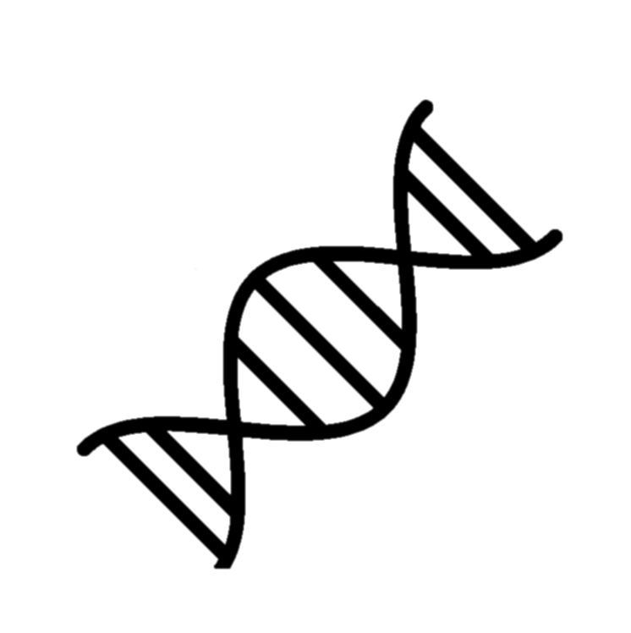
In this project, the reference database for Makrozoobenthos communities, targeted with the CO1 barcode region, will be improved. This includes the gathering of specimen, sequencing them and finally positioning them in a phylogenetic tree. In a second step, this tree will be used to assess the phylogenetic diversity from a swiss-wide biomonitoring using eDNA data. The project can start anytime.
TGCAT
ATGCAT
TATGCAT

We are looking for:
A motivated and independent person with a keen interest in aquatic community ecology who wants to learn about biodiversity analyses and who ideally has already some experience in molecular lab work. You will mainly be working at Eawag in a research group with diverse interests and expertise. If you want to know more about us, visit our website: altermattlab.ch.

If you are interested in the project, don’t hesitate to contact us:
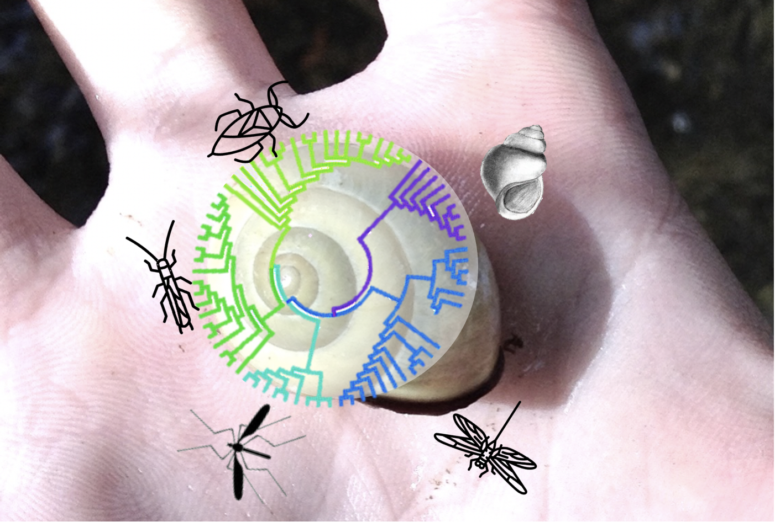
Jeanine Brantschen,
PhD supervising the project

jeanine.brantschen@eawag.ch

Prof. Dr. Florian Altermatt:

florian.altermatt@eawag.ch

MSc project in the group of Prof. Dr. Florian Altermatt
Department of Evolutionary Biology and Environmental studies at UZH
Department of Aquatic Ecology at Eawag

Taking the lab to the field: A novel tool to assess biodiversity in river systems
Using a “pocket sequencer” to assess the timescale of eDNA biomonitorings

Background:
In times of biodiversity loss, monitoring biodiversity in a fast and cost-efficient way is crucial. Molecular approaches have become valuable tools for biomonitorings. Recent technologies allow for fast assessments of biodiversity in the field that will change conservation and management of natural habitats.

Project aim:
This project investigates if changes in species composition can be tracked instantly by using a “pocket” (MinIon) sequencing platform that promises fast data gathering. We will collect a time series of eDNA samples from a river system and gain insight about the aquatic communities in these habitats. In particular, we will look at the time scales and consistency of species’ signals found in the eDNA samples taking into account statistical approaches (e.g. occupancy models).
TGCAT
ATGCAT
TATGCAT

We are looking for:
A motivated person with a high level of self-organization, who wants to learn about biodiversity in aquatic environments, who is able to deal with large datasets and who ideally brings along some experience in molecular lab work. You will mainly be working at Eawag in a research group with diverse interests and expertise. If you want to know more about us, visit our website: altermattlab.ch.

If you are interested in the project, please contact us:
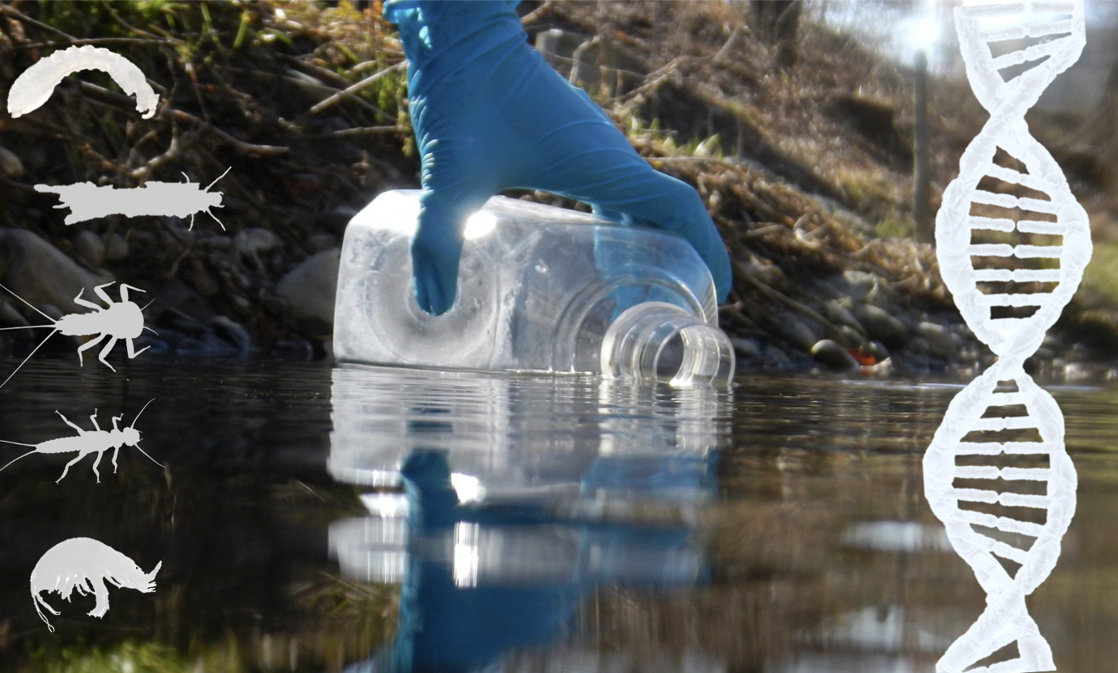
Jeanine Brantschen,
PhD student supervising the project:

jeanine.brantschen@eawag.ch

Prof. Dr. Florian Altermatt:

florian.altermatt@eawag.ch

